Using the data in the **Excel file provided**, (in LMS and in module 6) perform the following tasks:

1. Create a histogram comparing the distribution of monthly income for salespeople without attrition and salespeople with attrition

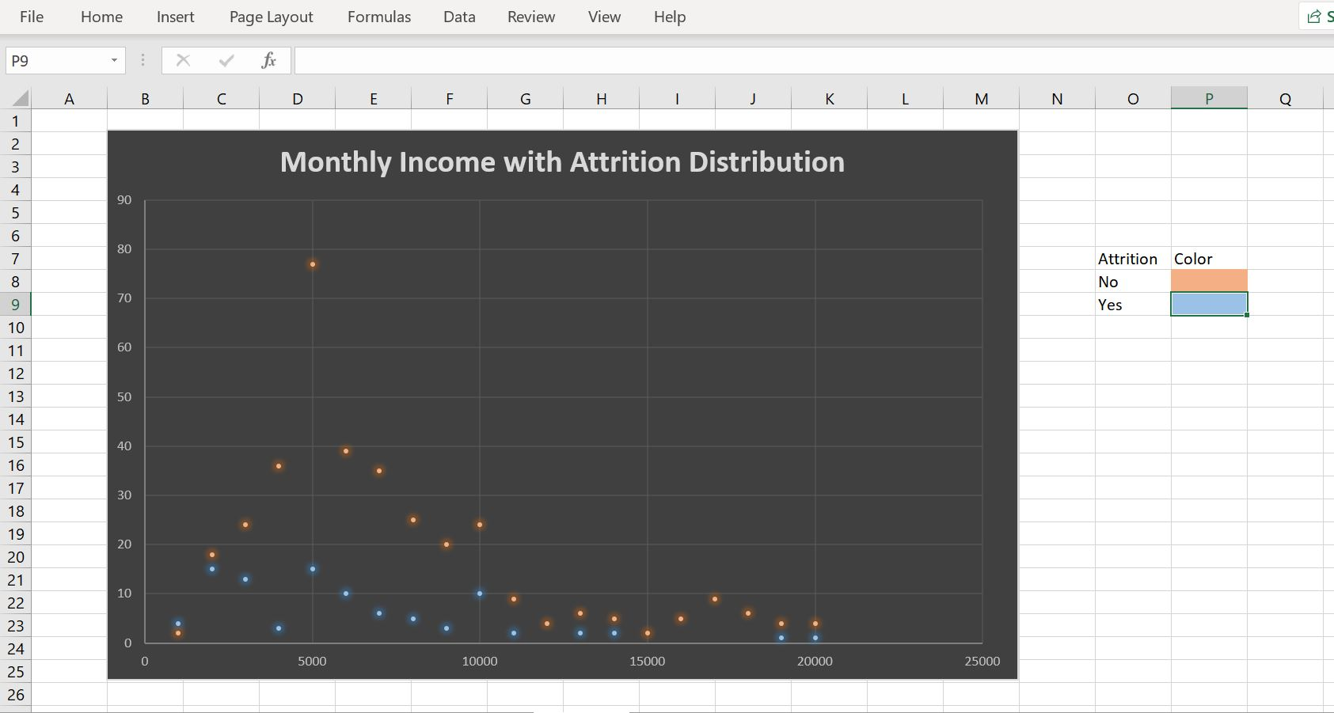

1. Create a dashboard for the count of salespeople with attrition and salespeople without attrition.

